Logic Gates Exercises

Build truth tables for following logic gates:

Question #1

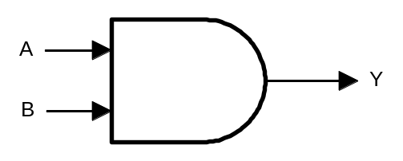
A | B | Y

Question #2

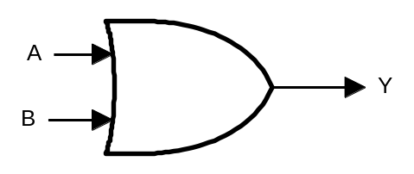
A | B | Y

Question #3

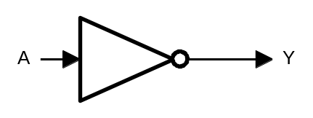
A | Y
For questions 4 to 13 use also Electronics Workbench software to design virtual circuits.

Question #4
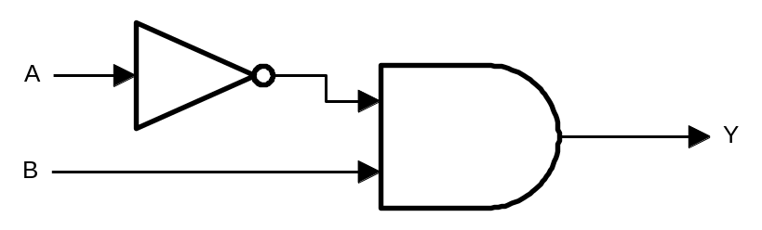

Question #5

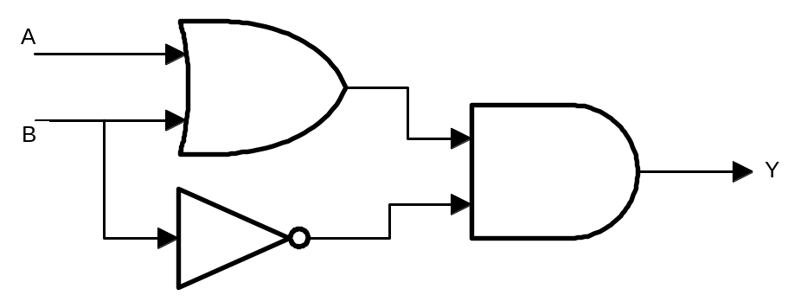

Question #6

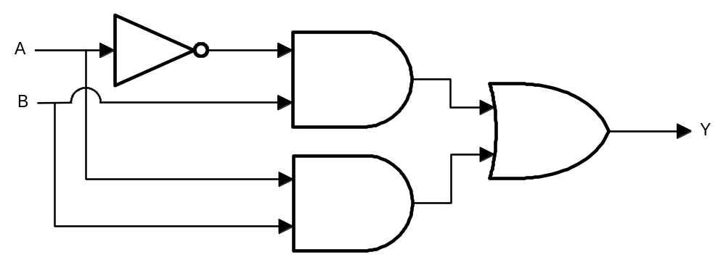

Question #7

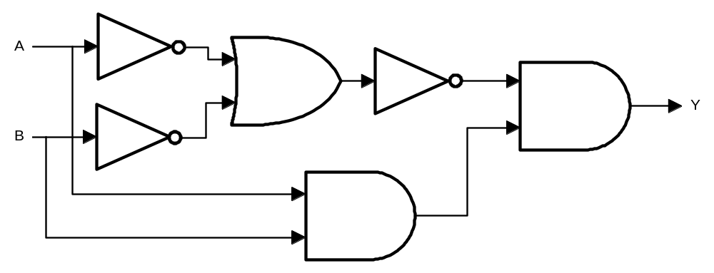

Question #8

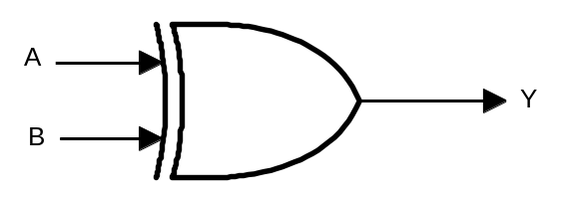

Question #9

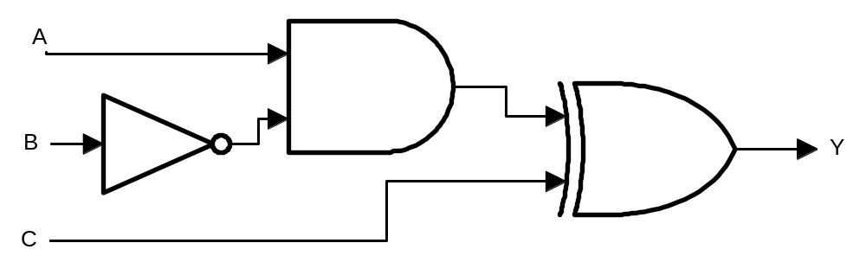

Question #10
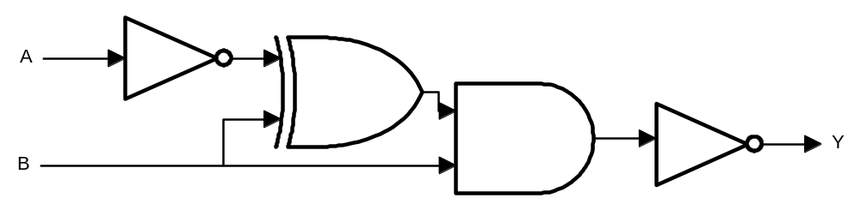

Question #11

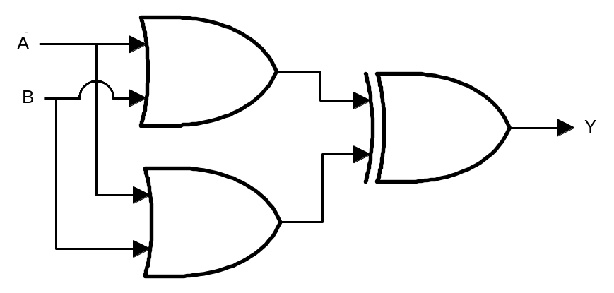

Question #12

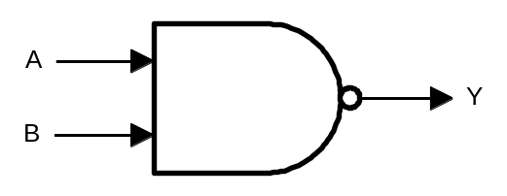

Question #13

